Maven installation:

Maven version:

$mvn –version

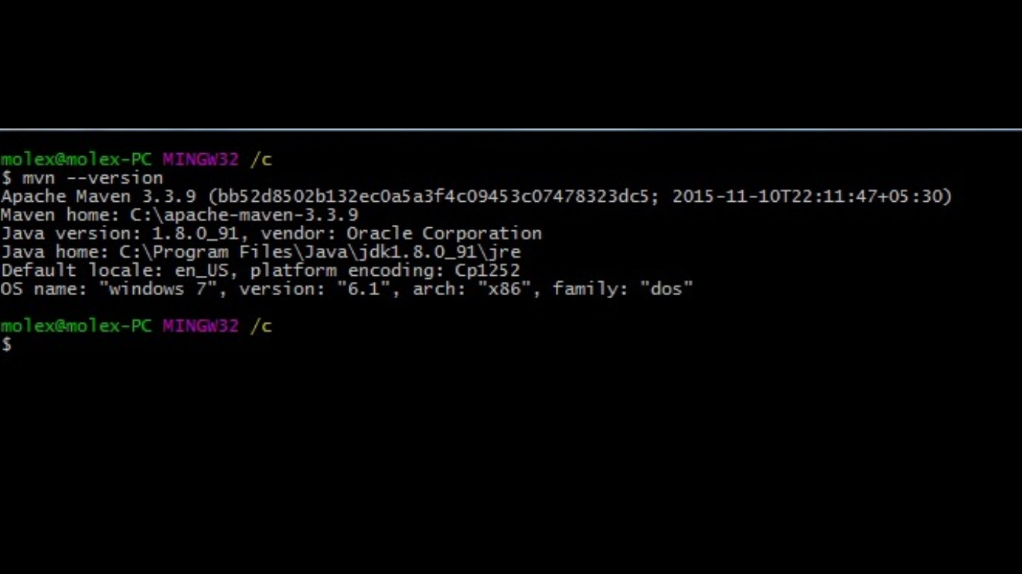

How to generate a maven project:

mvn archetype:generate

Choose org.apache.maven.archetypes:maven-archetype-quickstart version:

1: 1.0-alpha-1

2: 1.0-alpha-2

3: 1.0-alpha-3

4: 1.0-alpha-4

5: 1.0

6: 1.1

Choose a number: 6: 6

Define value for property 'groupId': : macy

Define value for property 'artifactId': : maven_project

Define value for property 'version': 1.0-SNAPSHOT: :

Define value for property 'package': macy: :

Confirm properties configuration:

groupId: macy

artifactId: maven_project

version: 1.0-SNAPSHOT

package: macy

Y: : y

[INFO] ----------------------------------------------------------------------------

[INFO] Using following parameters for creating project from Old (1.x) Archetype: maven-archetype-quickstart:1.1

[INFO] ----------------------------------------------------------------------------

[INFO] Parameter: basedir, Value: C:\maven_project

[INFO] Parameter: package, Value: macy

[INFO] Parameter: groupId, Value: macy

[INFO] Parameter: artifactId, Value: maven_project

[INFO] Parameter: packageName, Value: macy

[INFO] Parameter: version, Value: 1.0-SNAPSHOT

[INFO] project created from Old (1.x) Archetype in dir: C:\maven_project\maven_project

[INFO] ------------------------------------------------------------------------

[INFO] BUILD SUCCESS

[INFO] ------------------------------------------------------------------------

[INFO] Total time: 01:38 min

[INFO] Finished at: 2016-10-12T20:05:31+05:30

[INFO] Final Memory: 16M/247M

[INFO] ------------------------------------------------------------------------

Generated pom file is:

<g roupId>macy</groupId>

<artifactId>maven_project</artifactId>

<version>1.0-SNAPSHOT</version>

<packaging>jar</packaging>

<name>maven_project</name>

<url>http://maven.apache.org</url>

<properties>

<project.build.sourceEncoding>UTF-8</project.build.sourceEncoding>

</properties>

<dependencies>

<dependency>

<groupId>junit</groupId>

<artifactId>junit</artifactId>

<version>3.8.1</version>

<scope>test</scope>

</dependency>

</dependencies>

</project>

Maven Build Cycle activities:

**validate**: validate the project is correct and all necessary information is available.

molex@molex-PC MINGW32 /c/maven_project/maven_project

$ mvn validate

[INFO] Scanning for projects...

[INFO]

[INFO] ------------------------------------------------------------------------

[INFO] Building maven_project 1.0-SNAPSHOT

[INFO] ------------------------------------------------------------------------

[INFO] ------------------------------------------------------------------------

[INFO] BUILD SUCCESS

[INFO] ------------------------------------------------------------------------

[INFO] Total time: 0.135 s

[INFO] Finished at: 2016-10-12T20:09:57+05:30

[INFO] Final Memory: 12M/247M

[INFO] ------------------------------------------------------------------------

**compile**: compile the source code of the project

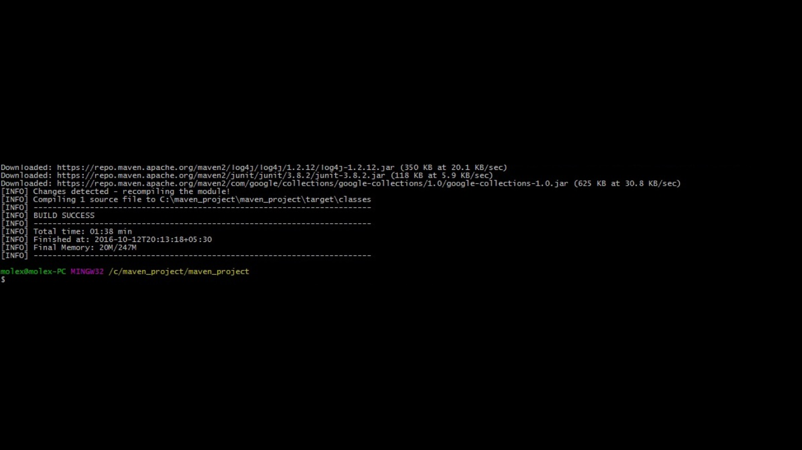

**test**: test the compiled source code using a suitable unit testing framework. These tests should not require the code be packaged or deployed.

-------------------------------------------------------

T E S T S

-------------------------------------------------------

Running macy.AppTest

Tests run: 1, Failures: 0, Errors: 0, Skipped: 0, Time elapsed: 0.003 sec

Results :

Tests run: 1, Failures: 0, Errors: 0, Skipped: 0

[INFO] ------------------------------------------------------------------------

[INFO] BUILD SUCCESS

[INFO] ------------------------------------------------------------------------

[INFO] Total time: 27.609 s

[INFO] Finished at: 2016-10-12T20:16:17+05:30

[INFO] Final Memory: 20M/247M

[INFO] ------------------------------------------------------------------------

**package**: take the compiled code and package it in its distributable format, such as a JAR

$ mvn package

[INFO] Scanning for projects...

[INFO]

[INFO] ------------------------------------------------------------------------

[INFO] Building maven_project 1.0-SNAPSHOT

[INFO] ------------------------------------------------------------------------

Downloading: https://repo.maven.apache.org/maven2/org/apache/maven/plugins/maven-jar-plugin/2.4/maven-jar-plugin-2.4.pom

Downloaded: https://repo.maven.apache.org/maven2/org/apache/maven/plugins/maven-jar-plugin/2.4/maven-jar-plugin-2.4.pom (6 KB at 3.1 KB/sec)

Downloading: https://repo.maven.apache.org/maven2/org/apache/maven/plugins/maven-jar-plugin/2.4/maven-jar-plugin-2.4.jar

Downloaded: https://repo.maven.apache.org/maven2/org/apache/maven/plugins/maven-jar-plugin/2.4/maven-jar-plugin-2.4.jar (34 KB at 32.2 KB/sec)

[INFO]

[INFO] --- maven-resources-plugin:2.6:resources (default-resources) @ maven_project ---

[INFO] Using 'UTF-8' encoding to copy filtered resources.

[INFO] skip non existing resourceDirectory C:\maven_project\maven_project\src\main\resources

[INFO]

[INFO] --- maven-compiler-plugin:3.1:compile (default-compile) @ maven_project ---

[INFO] Nothing to compile - all classes are up to date

[INFO]

[INFO] --- maven-resources-plugin:2.6:testResources (default-testResources) @ maven_project ---

[INFO] Using 'UTF-8' encoding to copy filtered resources.

[INFO] skip non existing resourceDirectory C:\maven_project\maven_project\src\test\resources

[INFO]

[INFO] --- maven-compiler-plugin:3.1:testCompile (default-testCompile) @ maven_project ---

[INFO] Nothing to compile - all classes are up to date

[INFO]

[INFO] --- maven-surefire-plugin:2.12.4:test (default-test) @ maven_project ---

[INFO] Surefire report directory: C:\maven_project\maven_project\target\surefire-reports

-------------------------------------------------------

T E S T S

-------------------------------------------------------

Running macy.AppTest

Tests run: 1, Failures: 0, Errors: 0, Skipped: 0, Time elapsed: 0.007 sec

Results :

Tests run: 1, Failures: 0, Errors: 0, Skipped: 0

[INFO]

[INFO] --- maven-jar-plugin:2.4:jar (default-jar) @ maven_project ---

Downloading: https://repo.maven.apache.org/maven2/org/apache/maven/maven-archiver/2.5/maven-archiver-2.5.pom

Downloaded: https://repo.maven.apache.org/maven2/org/apache/maven/maven-archiver/2.5/maven-archiver-2.5.pom (5 KB at 3.5 KB/sec)

Downloading: https://repo.maven.apache.org/maven2/org/codehaus/plexus/plexus-archiver/2.1/plexus-archiver-2.1.pom

Downloaded: https://repo.maven.apache.org/maven2/org/codehaus/plexus/plexus-archiver/2.1/plexus-archiver-2.1.pom (3 KB at 4.4 KB/sec)

Downloading: https://repo.maven.apache.org/maven2/org/codehaus/plexus/plexus-utils/3.0/plexus-utils-3.0.pom

Downloaded: https://repo.maven.apache.org/maven2/org/codehaus/plexus/plexus-utils/3.0/plexus-utils-3.0.pom (4 KB at 6.5 KB/sec)

Downloading: https://repo.maven.apache.org/maven2/org/sonatype/spice/spice-parent/16/spice-parent-16.pom

Downloaded: https://repo.maven.apache.org/maven2/org/sonatype/spice/spice-parent/16/spice-parent-16.pom (9 KB at 11.0 KB/sec)

Downloading: https://repo.maven.apache.org/maven2/org/sonatype/forge/forge-parent/5/forge-parent-5.pom

Downloaded: https://repo.maven.apache.org/maven2/org/sonatype/forge/forge-parent/5/forge-parent-5.pom (9 KB at 11.2 KB/sec)

Downloading: https://repo.maven.apache.org/maven2/org/codehaus/plexus/plexus-io/2.0.2/plexus-io-2.0.2.pom

Downloaded: https://repo.maven.apache.org/maven2/org/codehaus/plexus/plexus-io/2.0.2/plexus-io-2.0.2.pom (2 KB at 2.2 KB/sec)

Downloading: https://repo.maven.apache.org/maven2/org/codehaus/plexus/plexus-components/1.1.19/plexus-components-1.1.19.pom

Downloaded: https://repo.maven.apache.org/maven2/org/codehaus/plexus/plexus-components/1.1.19/plexus-components-1.1.19.pom (3 KB at 4.4 KB/sec)

Downloading: https://repo.maven.apache.org/maven2/org/codehaus/plexus/plexus/3.0.1/plexus-3.0.1.pom

Downloaded: https://repo.maven.apache.org/maven2/org/codehaus/plexus/plexus/3.0.1/plexus-3.0.1.pom (19 KB at 23.7 KB/sec)

Downloading: https://repo.maven.apache.org/maven2/org/codehaus/plexus/plexus-interpolation/1.15/plexus-interpolation-1.15.pom

Downloaded: https://repo.maven.apache.org/maven2/org/codehaus/plexus/plexus-interpolation/1.15/plexus-interpolation-1.15.pom (1018 B at 1.5 KB/sec)

Downloading: https://repo.maven.apache.org/maven2/classworlds/classworlds/1.1-alpha-2/classworlds-1.1-alpha-2.jar

Downloading: https://repo.maven.apache.org/maven2/org/apache/maven/maven-archiver/2.5/maven-archiver-2.5.jar

Downloading: https://repo.maven.apache.org/maven2/org/codehaus/plexus/plexus-interpolation/1.15/plexus-interpolation-1.15.jar

Downloading: https://repo.maven.apache.org/maven2/org/codehaus/plexus/plexus-io/2.0.2/plexus-io-2.0.2.jar

Downloading: https://repo.maven.apache.org/maven2/org/codehaus/plexus/plexus-archiver/2.1/plexus-archiver-2.1.jar

Downloaded: https://repo.maven.apache.org/maven2/classworlds/classworlds/1.1-alpha-2/classworlds-1.1-alpha-2.jar (37 KB at 41.2 KB/sec)

Downloading: https://repo.maven.apache.org/maven2/org/codehaus/plexus/plexus-utils/3.0/plexus-utils-3.0.jar

Downloaded: https://repo.maven.apache.org/maven2/org/codehaus/plexus/plexus-utils/3.0/plexus-utils-3.0.jar (221 KB at 74.7 KB/sec)

Downloaded: https://repo.maven.apache.org/maven2/org/codehaus/plexus/plexus-interpolation/1.15/plexus-interpolation-1.15.jar (60 KB at 18.9 KB/sec)

Downloaded: https://repo.maven.apache.org/maven2/org/codehaus/plexus/plexus-archiver/2.1/plexus-archiver-2.1.jar (181 KB at 46.0 KB/sec)

Downloaded: https://repo.maven.apache.org/maven2/org/codehaus/plexus/plexus-io/2.0.2/plexus-io-2.0.2.jar (57 KB at 10.0 KB/sec)

Downloaded: https://repo.maven.apache.org/maven2/org/apache/maven/maven-archiver/2.5/maven-archiver-2.5.jar (22 KB at 3.6 KB/sec)

[INFO] Building jar: C:\maven_project\maven_project\target\maven_project-1.0-SNAPSHOT.jar

[INFO] ------------------------------------------------------------------------

[INFO] BUILD SUCCESS

[INFO] ------------------------------------------------------------------------

[INFO] Total time: 18.213 s

[INFO] Finished at: 2016-10-12T20:17:39+05:30

[INFO] Final Memory: 16M/247M

[INFO] ------------------------------------------------------------------------

**VERIFY**: run any checks to verify the package is valid and meets quality criteria

$ mvn verify

[INFO] Scanning for projects...

[INFO]

[INFO] ------------------------------------------------------------------------

[INFO] Building maven_project 1.0-SNAPSHOT

[INFO] ------------------------------------------------------------------------

[INFO]

[INFO] --- maven-resources-plugin:2.6:resources (default-resources) @ maven_project ---

[INFO] Using 'UTF-8' encoding to copy filtered resources.

[INFO] skip non existing resourceDirectory C:\maven_project\maven_project\src\main\resources

[INFO]

[INFO] --- maven-compiler-plugin:3.1:compile (default-compile) @ maven_project ---

[INFO] Nothing to compile - all classes are up to date

[INFO]

[INFO] --- maven-resources-plugin:2.6:testResources (default-testResources) @ maven_project ---

[INFO] Using 'UTF-8' encoding to copy filtered resources.

[INFO] skip non existing resourceDirectory C:\maven_project\maven_project\src\test\resources

[INFO]

[INFO] --- maven-compiler-plugin:3.1:testCompile (default-testCompile) @ maven_project ---

[INFO] Nothing to compile - all classes are up to date

[INFO]

[INFO] --- maven-surefire-plugin:2.12.4:test (default-test) @ maven_project ---

[INFO] Surefire report directory: C:\maven_project\maven_project\target\surefire-reports

-------------------------------------------------------

T E S T S

-------------------------------------------------------

Running macy.AppTest

Tests run: 1, Failures: 0, Errors: 0, Skipped: 0, Time elapsed: 0.004 sec

Results :

Tests run: 1, Failures: 0, Errors: 0, Skipped: 0

[INFO]

[INFO] --- maven-jar-plugin:2.4:jar (default-jar) @ maven_project ---

[INFO] ------------------------------------------------------------------------

[INFO] BUILD SUCCESS

[INFO] ------------------------------------------------------------------------

[INFO] Total time: 2.130 s

[INFO] Finished at: 2016-10-12T20:18:41+05:30

[INFO] Final Memory: 11M/247M

[INFO] ------------------------------------------------------------------------

**INSTALL**: install the package into the local repository, for use as a dependency in other projects locally.

[INFO] Installing C:\maven_project\maven_project\target\maven_project-1.0-SNAPSHOT.jar to C:\Users\molex\.m2\repository\macy\maven_project\1.0-SNAPSHOT\maven_project-1.0-SNAPSHOT.jar

[INFO] Installing C:\maven_project\maven_project\pom.xml to C:\Users\molex\.m2\repository\macy\maven_project\1.0-SNAPSHOT\maven_project-1.0-SNAPSHOT.pom

[INFO] ------------------------------------------------------------------------

[INFO] BUILD SUCCESS

[INFO] ------------------------------------------------------------------------

[INFO] Total time: 11.624 s

[INFO] Finished at: 2016-10-12T20:19:37+05:30

[INFO] Final Memory: 16M/247M

[INFO] ------------------------------------------------------------------------

**deploy**: done in an integration or release environment, copies the final package to the remote repository for sharing with other developers and projects